Homework 1

Sanduni Talagala

January 13, 2020

## R Markdown

This is an R Markdown document. Markdown is a simple formatting syntax for authoring HTML, PDF, and MS Word documents. For more details on using R Markdown see <http://rmarkdown.rstudio.com>.

When you click the **Knit** button a document will be generated that includes both content as well as the output of any embedded R code chunks within the document. You can embed an R code chunk like this:

**Qustion 1: Creating vectors**

Transgenic_strain_A = c(0.17,0.20,0.13,0.20,0.24,0.25,0.15,0.21,0.21)  
Transgenic_strain_B = c(0.47,0.21,0.34,0.32,0.33,0.29,0.18,0.20,0.25)  
Common_strain = c(0.44,0.33,0.37,0.33,0.31,0.27,0.22,0.30,0.28)

**Question 2: Difference of means**

MeanTransA<-mean(Transgenic_strain_A)  
MeanTransB<-mean(Transgenic_strain_B)  
MeanDifference<-MeanTransA-MeanTransB  
MeanDifference

## [1] -0.09222222

**Question 3: Difference of means**

MeanCommon<-mean(Common_strain)  
MeanDifference2<-MeanCommon-MeanTransA  
MeanDifference2

## [1] 0.1211111

**Question 4: Historgram for common strand**

hist(Common_strain, main="Histogram of hydrogen peroxide in common strain plant",xlab="concentration of hydrogen peroxide (μmoles/g)", ylab="frequency")

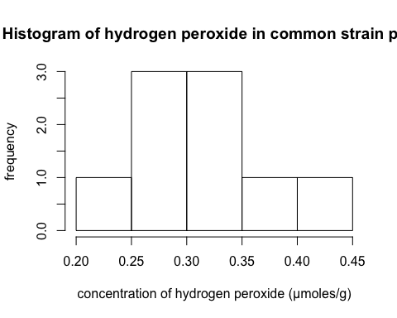

**Question 5: Growth rate data frame**

Hydrogen_Peroxide_Concentration = c(0.27,0.21,0.34,0.32,0.24,0.29,0.18,0.20,0.29)  
Fungal_Growth_Rate = c(1.79,1.01,1.71,1.89,1.41,1.15,1.13,1.20,1.10)  
Peroxide_Growth=data.frame('Peroxide' = Hydrogen_Peroxide_Concentration, 'Growth.rate' = Fungal_Growth_Rate)  
Peroxide_Growth

## Peroxide Growth.rate  
## 1 0.27 1.79  
## 2 0.21 1.01  
## 3 0.34 1.71  
## 4 0.32 1.89  
## 5 0.24 1.41  
## 6 0.29 1.15  
## 7 0.18 1.13  
## 8 0.20 1.20  
## 9 0.29 1.10

**Question 6: Scatter plot of fungal growth due to peroxide**

plot(Peroxide_Growth$Peroxide,Peroxide_Growth$Growth.rate,xlab='Hydrogen peroxide concentration (μmoles/g)',ylab='Fungal growth rate (cm/day)',main='Hydrogen peroxide concentration vs fungal growth')

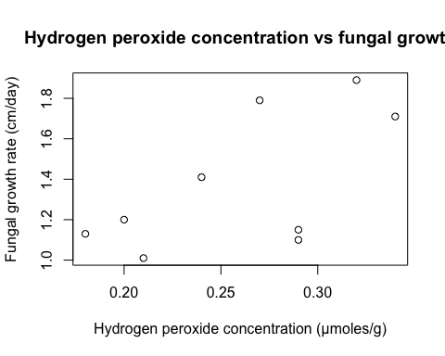

**Question 7: Hypothesis testing** Yes,fungal growth rate increases with hyghdrogen peroxide concentration. This disagrees with the hypothesis.

**Question 8: Read CSV**

Turtles=read.csv("612Homework1TurtleSuccess.csv")  
Turtles

## Nesting.status Species  
## 1 Success OliveRidley  
## 2 Success OliveRidley  
## 3 Success OliveRidley  
## 4 Success OliveRidley  
## 5 Success OliveRidley  
## 6 Success OliveRidley  
## 7 Success OliveRidley  
## 8 Success OliveRidley  
## 9 Success OliveRidley  
## 10 Success OliveRidley  
## 11 Success OliveRidley  
## 12 Success OliveRidley  
## 13 Success OliveRidley  
## 14 Success OliveRidley  
## 15 Success OliveRidley  
## 16 Success OliveRidley  
## 17 Aborted OliveRidley  
## 18 Aborted OliveRidley  
## 19 Aborted OliveRidley  
## 20 Aborted OliveRidley  
## 21 Success Hawksbill  
## 22 Success Hawksbill  
## 23 Success Hawksbill  
## 24 Success Hawksbill  
## 25 Aborted Hawksbill  
## 26 Aborted Hawksbill  
## 27 Aborted Hawksbill  
## 28 Success Leatherback  
## 29 Success Leatherback  
## 30 Success Leatherback  
## 31 Success Leatherback  
## 32 Aborted Leatherback  
## 33 Aborted Leatherback

**Question 9: Contingency table**

my.table<-table(Turtles)  
my.table

## Species  
## Nesting.status Hawksbill Leatherback OliveRidley  
## Aborted 3 2 4  
## Success 4 4 16

**Question 10: Barplot** ———>Please note that here I created another table (Turtles2) with excel shown below as it is suggested in the tutorial to arrange the data in a specific way for ggplot and make another table.

library(ggplot2)  
Turtles2=read.csv("612Homework1Barplot.csv")  
Turtles2

## NestingStatus Counts Species  
## 1 Aborted 4 OliveRidley  
## 2 Success 16 OliveRidley  
## 3 Aborted 3 Hawksbill  
## 4 Success 4 Hawksbill  
## 5 Aborted 2 Leatherback  
## 6 Success 4 Leatherback

ggplot(data=Turtles2, aes(x=Species, y=Counts, fill=NestingStatus)) + geom_bar(stat="identity", position=position_dodge()) + scale_fill_manual(values = c("red","green"))+  
 labs(x="Species",y="Aborted or successful nesting attempts of turtles (counts)")+ ggtitle ("Nesting attempts of three species of turtles")

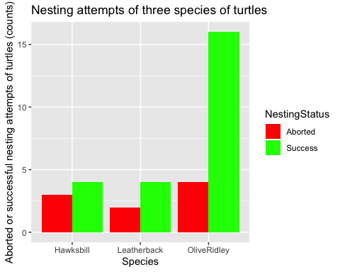

**Question 11: Mean and standard deviation**

MeanSuccess = mean(my.table[2,])  
MeanSuccess

## [1] 8

SDSuccess = sd(my.table[2,])  
SDSuccess

## [1] 6.928203

**Question 12: Proportions: Code**

pFailedOliveRidely = my.table[1,3]/(sum(my.table[1,3],my.table[2,3]))  
pFailedOliveRidely

## [1] 0.2

pFailedLeatherback = my.table[1,2]/(sum(my.table[1,2],my.table[2,2]))  
pFailedLeatherback

## [1] 0.3333333

pFailedHawksbill = my.table[1,1]/(sum(my.table[1,1],my.table[2,1]))  
pFailedHawksbill

## [1] 0.4285714

**Question 12: Conservation efforts: explanation** OliveRidley turtles had a faliure proportion of 0.2, whole Hawksbill had 0.43 and Leatherback had 0.33 proportion of faliure. This means that Hawksbill turtles had the biggest proortion of failed attempts at netsting out of all the attempts, making them the speacies that needs the most conservation efforts

**Question 13:Import nest egg counts**

EggCount=read.csv("NestEgg.csv", encoding = getOption("encoding"))  
EggCount

## Nest OliveRidley Hawksbill Leatherback  
## 1 1 127 143 149  
## 2 2 110 144 143  
## 3 3 112 124 128  
## 4 4 110 145 111  
## 5 5 118 122 110  
## 6 6 115 132 109  
## 7 7 120 121 110  
## 8 8 108 127 105  
## 9 9 120 151 89  
## 10 10 126 105 98  
## 11 11 114 141 112  
## 12 12 130 132 108  
## 13 13 123 145 109  
## 14 14 128 132 101  
## 15 15 121 151 97  
## 16 16 109 111 110

**Question 14: Boxplot**

boxplot(EggCount$OliveRidley,EggCount$Hawksbill,EggCount$Leatherback,names=c("Olive Ridley",  
"Hawksbill","Leatherback"),main="Eggs laid by different species in observed nests",  
ylab='Number of eggs (count)',xlab='Species',col=  
c('red','blue','green'))

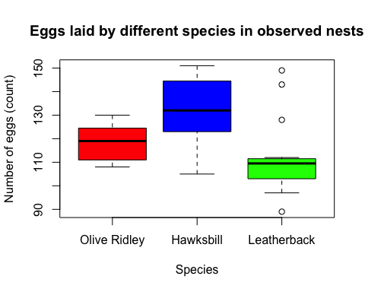

**Question 15: Scatterplot Hawksbill turtle eggs vs leatherback turtle eggs**

plot(EggCount$Hawksbill,EggCount$Leatherback,xlab='Hawksbill eggs in the nests (count)',ylab='Leatherback eggs in the nests (count)',main='Scatter plot of Hawksbill eggs vs Leatherback eggs')

